Code:

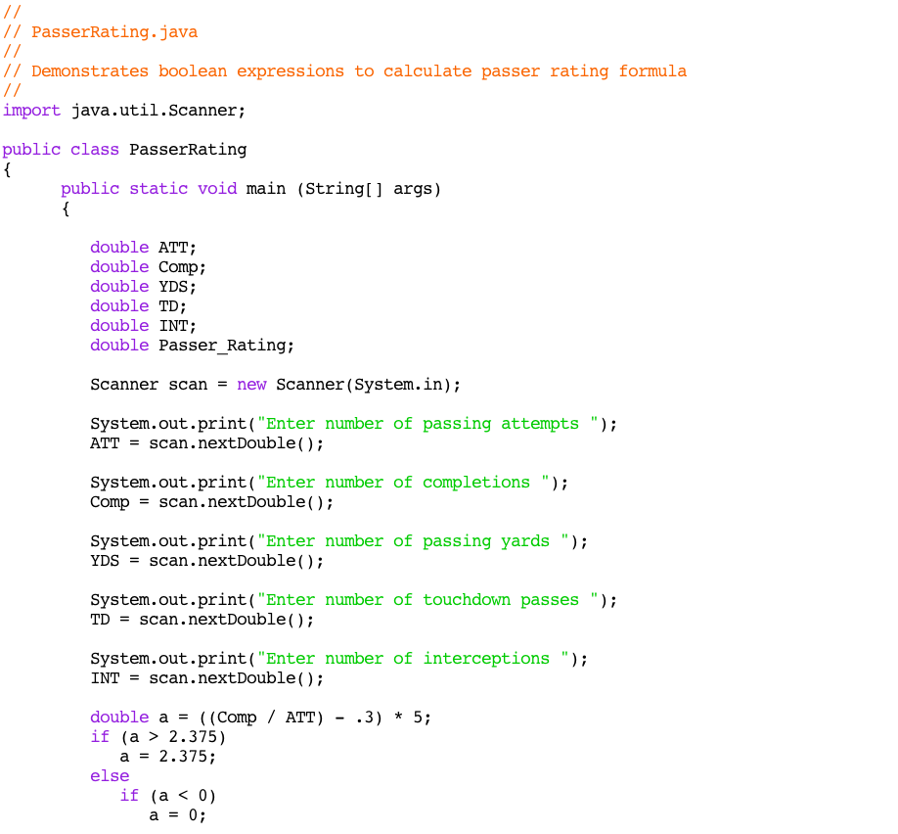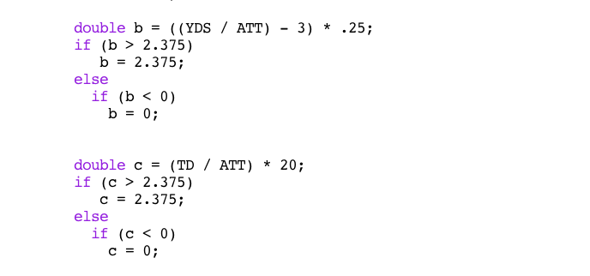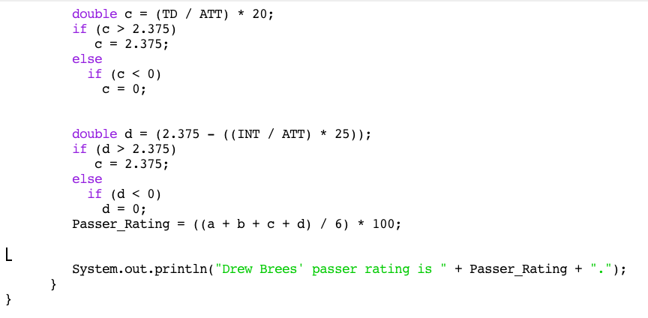

Output:

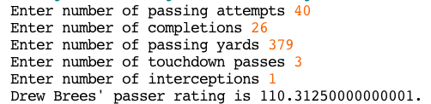

Just a couple things:

With your comparisons like this:

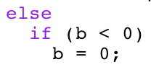

You don't need the following:

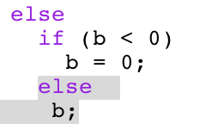

The code automatically assumes that if b is less than 0, nothing is changed! Also a line like "b;" crashes the program.

Also, according to the formula, using the data you provided, Drew Brees actually had a score of 110, not 81 (something seemed to have been off with your d section).

Otherwise, well done, and great choice of problem!